Name | Arsh Raina
UID no. | 2021600053
Experiment No. | 2

AIM: | Apply various control structures to solve given problems.
Program 1
PROBLEM STATEMENT : | // Write a program to convert a decimal number to binary number.
ALGORITHM: | Step 1: Declare a variable n to store decimal, b=0 to store in binary number, rem to store modulus and i equal to one.  Step 2: Input and store value of n.  Step 3: Declare a variable temp to store a copy of decimal number.  Step 4: Start a while loop which runs till n is not equal to zero.  Step 5: In each iteration, store n modulus 2 in rem, divide n by 2, add product of rem and i to b and multiply i by 10.  Step 6: Print b.
FLOWCHART: | 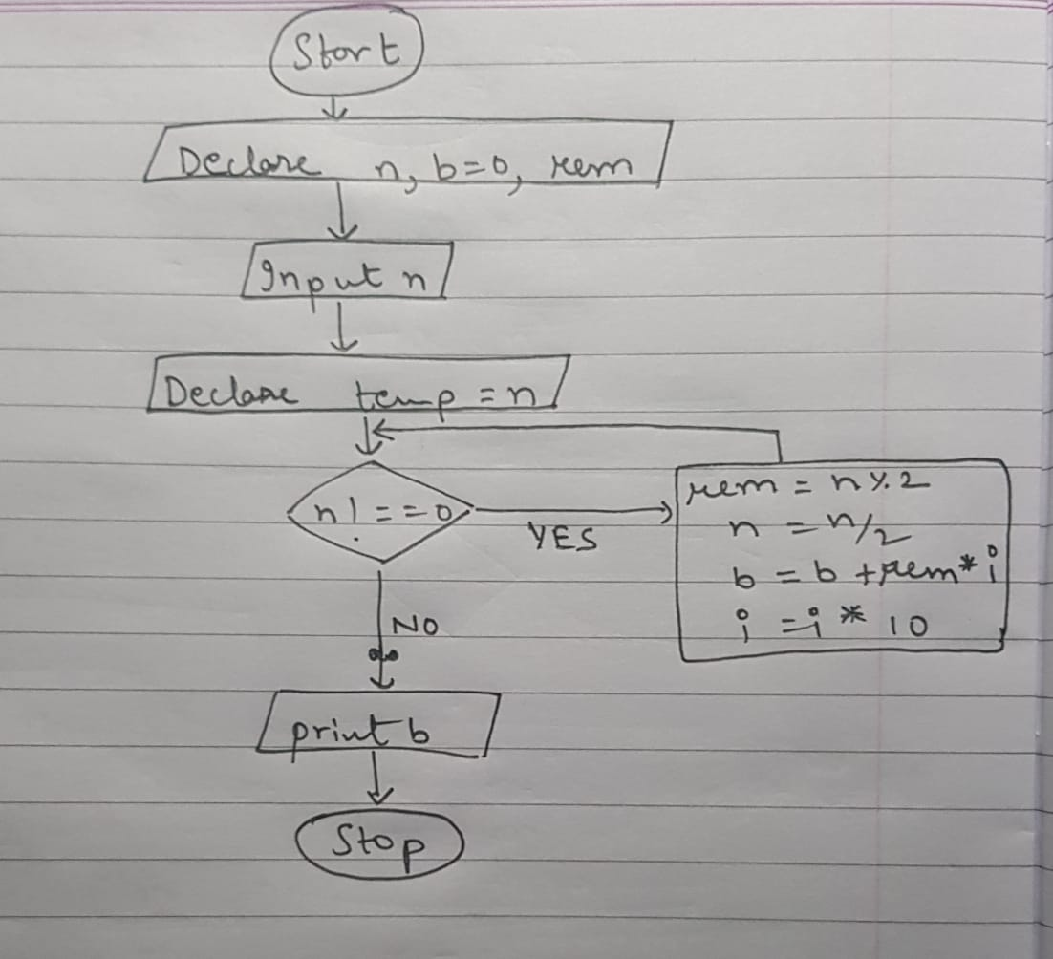
PROGRAM: | #include <stdio.h>  int main() {  int n,rem;  printf("Enter a decimal number: ");  scanf("%d", &n);  int b = 0;  int temp = n;  int i = 1;  while (n!=0) {  rem = n % 2;  n = n/2;  b = b + rem * i;  i = i * 10;  }  printf("decimal number %d in binary = %d \n", temp, b);  return 0;  }
RESULT:
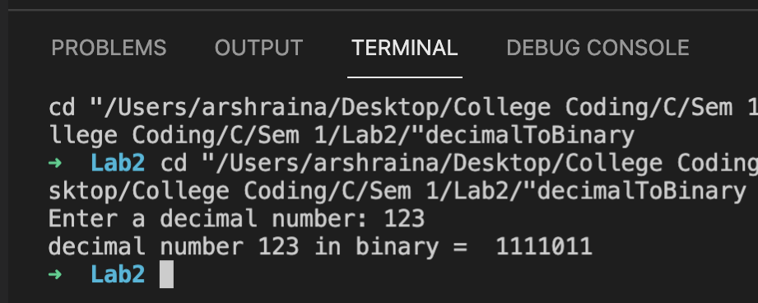
Program 2
PROBLEM STATEMENT : | // Write a program to find out whether a number is kaprekar or not.
ALGORITHM: | Step 1: Define a variable n to store the number, dig equal to zero, lhs to store left hand side digits, rhs to store right hand side digits and sq to store the square.  Step 2: Input and store the number in n.  Step 3: Store a copy of n in temp.  Step 4: Run a while loop till n is not zero.  Step 5: In each iteration, add one to dig and divide n by 10.  Step 6: Calculate 10 raised to power dig and store the value in x.  Step 7: Calculate sq modulus x and store in rhs.  Step 8: Calculate sq divided by x and store in lhs.  Step 9: If temp equals one, print that n is not Kaprekar number. Else if temp equals the sum of lhs and rhs, print that n is Kaprekar number. Else print that n is not Kaprekar number.
FLOWCHART:
PROGRAM: | #include <stdio.h>  #include <math.h>  int main() {  int n, dig = 0, x, lhs, rhs, sq;  printf ("Enter a number: ");  scanf ("%d", &n);  sq = n * n;  int temp = n;  while (n != 0) {  dig++;  n = n/10;  }  x = pow (10,dig);  rhs = sq % x;  lhs = sq/x;  if (temp == 1) {  printf("It is Kaprekar number.\n");  }  else {  if (temp == lhs + rhs) {  printf("It is Kaprekar number.\n");  }  else {  printf("Not Kaprekar number.\n");  }  }  return 0;  }
RESULT:
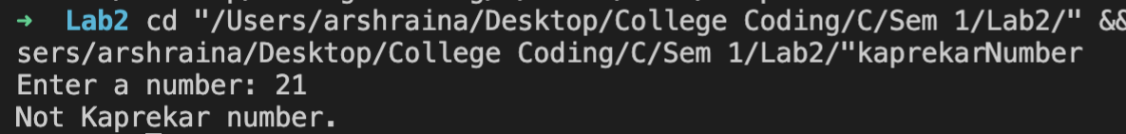
Program 3
PROBLEM STATEMENT: | // Write a program which inputs two positive integers A and B and outputs all twin primes in range A to B.
ALGORITHM: | Step 1: Declare function primeCheck using variable x. Declare variable A, variable B. Declare variable flag equal to zero.  Step 2: Input and store values of A and B.  Step 3: Run a for loop with variable i. The values of i must be in range A to B-1.  Step 4: Using primeCheck function, if i and i+2 are prime, print i and i+2 and change value of flag to 1.  Step 5: If flag equals zero print that there are no twin prime numbers in range.  Step 6: In primeCheck function, if x equals 1 return 0. Run a for loop using variable i, the values of I must be in range 2 to x-1. If x modulus i equals zero, return zero. Otherwise return 1.
FLOWCHART:
PROGRAM: | #include<stdio.h>  int primeCheck(int x);  int main(void) {  int A, B, flag = 0;  printf("Enter A and B separated by a comma: ");  scanf("%d,%d", &A, &B);  for(int i = A; i < B; i++) {  if(primeCheck(i) && primeCheck(i + 2)) {  printf("%d & %d\n", i, i + 2);  flag = 1;  i++;  }  }  if (flag == 0) {  printf("No twin prime numbers in given range!\n");  }  return 0;  }  int primeCheck(int x) {  if(x == 1){  return 0;  }  for(int i = 2; i < x; i++) {  if(x % i == 0){  return 0;  }  }  return 1;  }
RESULT:
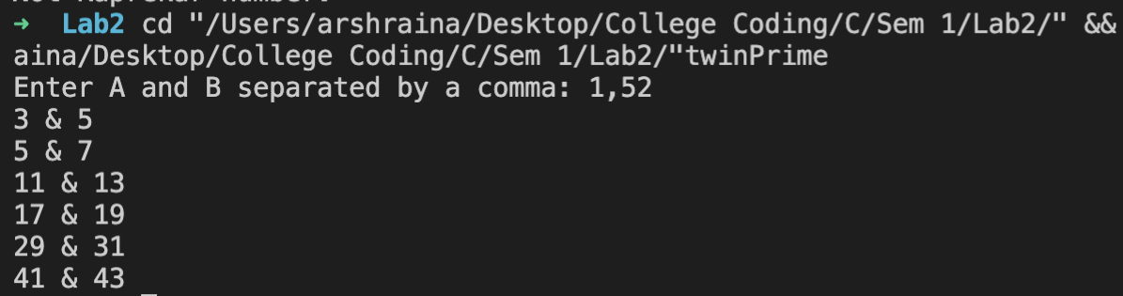
Program 4
PROBLEM STATEMENT: | // There is a property that (10a+b)*(10c+d) =(10b+a)(10d+c) where a and b are unequal and c and d are also unequal. Write a program which outputs them all between 10 to 99.
ALGORITHM: | Step 1: Declare function rev using variable a.  Step 2: Start a for loop using variable i, the values of i are in range 10 to 99.  Step 3: Start another loop inside the loop using variable j, the values of j are in range 10 to 99. For each iteration if product of i and j equals the product of rev(i) and rev(j) & i not equal to rev(i) & i not equal to rev(j) & j not equal to rev(j) & j not equal to rev(i), print i, j, rev(i) and rev(j).  Step 4: In rev function, calculate a modulus 10 and store in variable x1, calculate a divided by 10 and store in variable x2. Calculate the product of x1 and 10 then add x2 to it, store the final value in r.
FLOWCHART:
PROGRAM: | 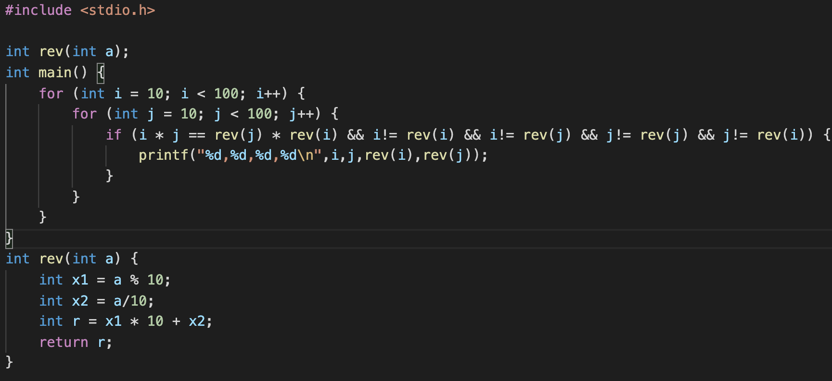
RESULT:

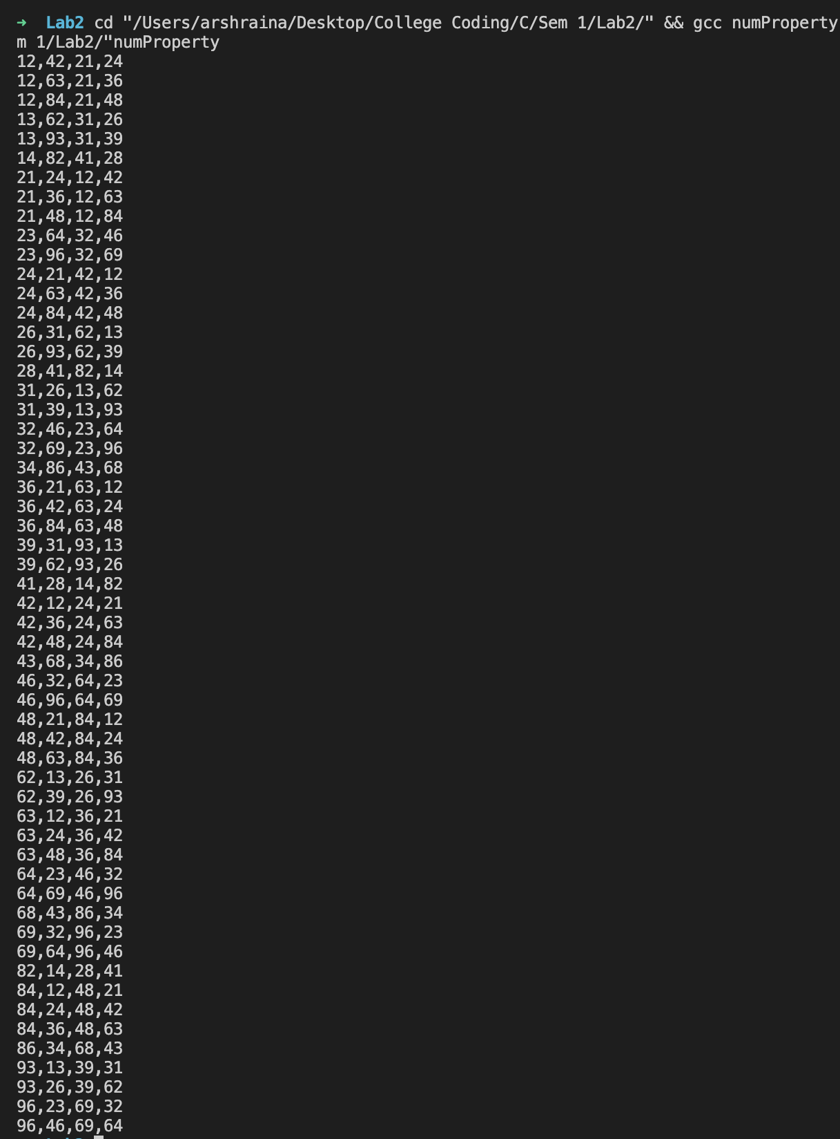
Program 5
PROBLEM STATEMENT: | // Take two numbers as input and calculate their LCM and GCD (HCF).
ALGORITHM: | Step 1: Declare variable n1, n2, gcd, lcm, small. Declare variable i equal to 1.  Step 2: Input and store value of n1 and n2.  Step 3: If n1 greater than n2 then small equals n2. Else small equals n1.  Step 4: Run a while loop, till i is less than or equal to small.  Step 5: In each iteration, if n1 modulus i equals zero and n2 modulus i equals zero, then store value of i in variable gcd, add 1 to i.  Step 6: Divide the product of n1 and n2 by gcd and store the final value in variable lcm.  Step 7: Print lcm and gcd.
FLOWCHART:
PROGRAM: | #include <stdio.h>  int main() {  int n1, n2, gcd, lcm, i = 1, small;  printf("Enter 2 integer numbers separate by comma\n");  scanf("%d,%d", &n1, &n2);  if (n1 > n2) {  small = n2;  }  else {  small = n1;  }  while(i <= small) {  if(n1 % i == 0 && n2 % i == 0) {  gcd = i;  }  i++;  }  lcm = ( n1 * n2 ) / gcd;  printf("GCD = %d\nLCM = %d\n", gcd, lcm);  return 0;  }
RESULT:
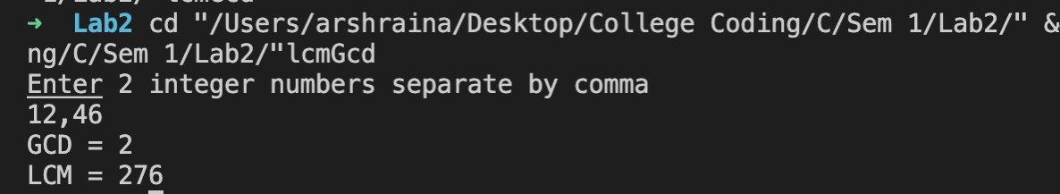
CONCLUSION: | Successfully learnt applications of various control structures.

